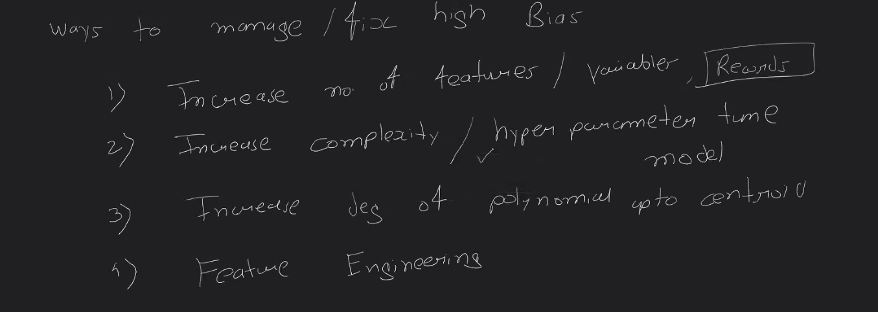

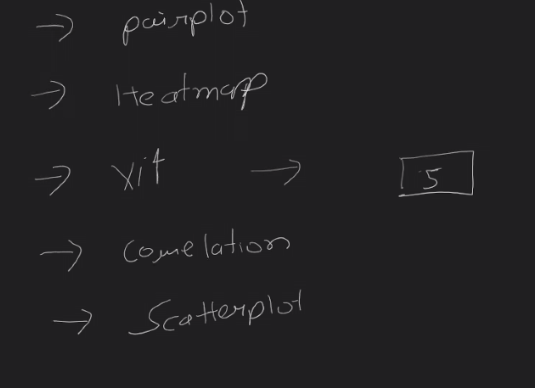   
Multicollinearity check



4) Mulicollinearily

5) Hyperparameter tuning

Identify Outliers:

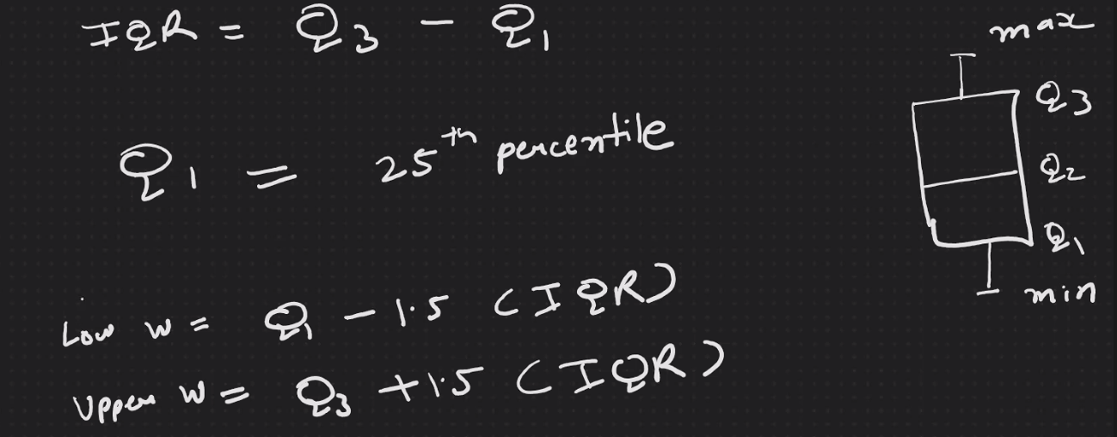

Min -> Lower W

Max -> Upper W

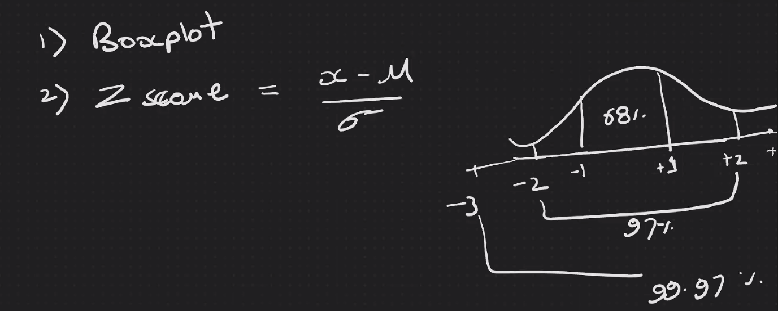



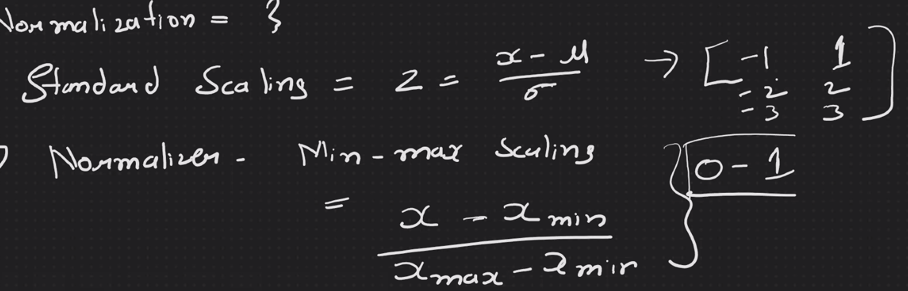

Robust Scaling – For outliers

Solve skewness:

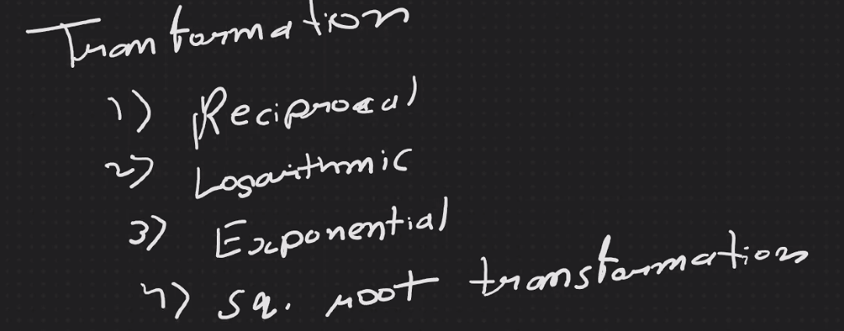

Checking for good fit model:

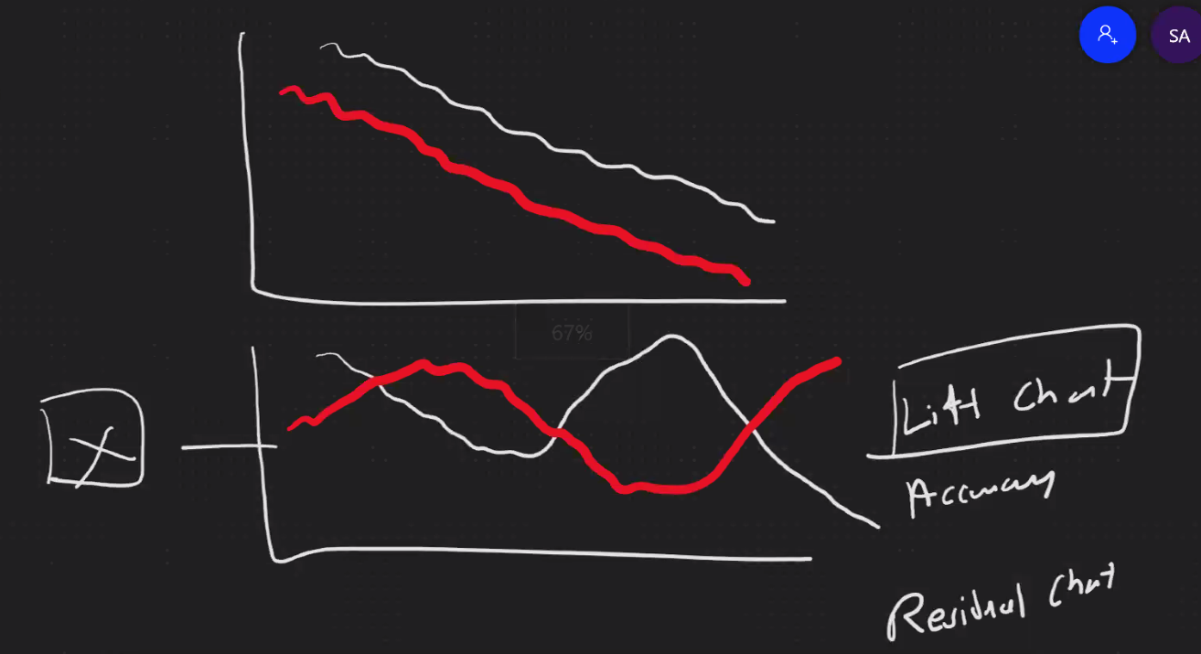

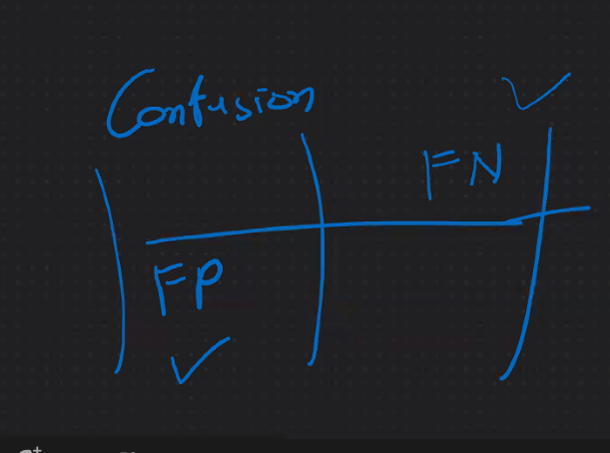

Sensitive to Outliers:

Linear Regression, Logistic Regression

Not Sensitive Outliers:

Ensemble, DT, SVM